**Data Analysis Report: Human Resources (HR) Analytics**

1. **Introduction**

This report provides an in-depth analysis of key Human Resources (HR) metrics such as employee headcount, turnover (attrition), diversity, compensation, employee satisfaction and workforce trends. The insights generated will assist HR in decision making, ensuring employee’s engagement and ensuring compliance with organizational and regulatory policies.

* 1. **Objective**

The primary objective of this report is to:

* Analyze critical HR metrics such as headcount, attrition, diversity, compensation and employee satisfaction.
* Provide a data-driven foundation for decision-making regarding employee retention, equity, compensation management and workforce development.
* Highlight specific areas of concern and propose strategic HR interventions.

1. **Data Overview**

The dataset used for analysis comprises of employee-related information which includes;

• Employee demographics (Gender, Age, Marital Status, Education Field)

• Employment details (Department, Job Role, Job Level, Job Involvement)

• Compensation data (Monthly Income, Salary Hike, Overtime)

• Satisfaction scores (Job Satisfaction, Jon Involvement, Work-Life Balance)

• Attrition records (Attrition status, Attrition Count)

• Performance ratings and tenure information (Years at Company, Years in Current Role)

1. **Analysis and Findings**

**3.1 Headcount Distribution *(****Refer to Annex 1 for detailed visualization of this distribution****)***

1. **By Department**

|  |  |
| --- | --- |
| **Department** | **Total No of Employees** |
| Research and Development | 961 |
| Sales | 446 |
| Human Resources | 63 |

1. **By Job role**

|  |  |
| --- | --- |
| **Job Role** | **Total No of Employees** |
| Sales Executives | 326 |
| Research Scientist | 292 |
| Laboratory Technician | 259 |
| Manufacturing Director | 145 |
| Healthcare Representative | 131 |
| Manager | 102 |
| Sales Representative | 83 |
| Research Director | 80 |
| Human Resources | 52 |

1. **By Gender**

|  |  |
| --- | --- |
| **Gender** | **Total No of Employees** |
| Male | 882 |
| Female | 588 |

1. **By Age Group**

|  |  |
| --- | --- |
| **Age Group** | **Total No of Employees** |
| 18-25 | 123 |
| 26-35 | 606 |
| 36-45 | 468 |
| 46-55 | 226 |
| 55+ | 47 |

**3.2 Attrition Analysis *(****Refer to Annex2 for detailed visualization of this distribution****)***

This the percentage of the Number of employees that has left the organization over a period of time in relation to the total employees in the organization. This helps organization to measure how often they lose employees. It is expressed as;

Attrition Rate $=\frac{AttritionCount}{Total Employee Count}×100$

Attrition Count = 237

Attrition Rate $=16.1\%$

1. **Attrition by Department**

|  |  |
| --- | --- |
| **Department** | **Attrition Count** |
| Research and Development | 133 |
| Sales | 92 |
| Human Resources | 12 |

1. **By Gender**

|  |  |
| --- | --- |
| **Gender** | **Attrition Count** |
| Male | 150 |
| Female | 87 |

1. **By Age Group**

|  |  |
| --- | --- |
| **Age Group** | **Attrition Count** |
| 18-25 | 44 |
| 26-35 | 116 |
| 36-45 | 43 |
| 46-55 | 26 |
| 55+ | 8 |

1. **Attrition by Job Satisfaction**

|  |  |
| --- | --- |
| **Job Satisfaction** | **Attrition Count** |
| 1 | 66 |
| 2 | 46 |
| 3 | 73 |
| 4 | 52 |

1. **Attrition by Job Involvement**

|  |  |
| --- | --- |
| **Job Involvement** | **Attrition Count** |
| 1 | 28 |
| 2 | 71 |
| 3 | 125 |
| 4 | 13 |

**3.3 Diversity Metrics *(****Refer to Annex 3 for detailed visualization of this distribution****)***

These are quantitative measurements used by an organization to track how diverse they are in various categories such as gender, age groups, Ethnicity/race, education background etc.

**Educational Field Distribution**

|  |  |
| --- | --- |
| **Educational Field** | **Total No of Employees** |
| Life Sciences | 606 |
| Medical | 464 |
| Marketing | 159 |
| Technical Degree | 132 |
| Human Resources | 27 |
| Others | 82 |

**Marital Status Distribution**

|  |  |
| --- | --- |
| **Marital Status** | **Total No of Employees** |
| Married | 673 |
| Single | 470 |
| Divorced | 327 |

**Gender Distribution**

|  |  |
| --- | --- |
| **Gender** | **Total No of Employees** |
| **Male** | 882 |
| **Female** | 588 |

**3.4 Compensation Insights *(****Refer to Annex 4 for detailed visualization of this distribution****)***

Compensation insights is the analysis of employee salary, benefits, bonuses and other financial rewards within an organization. This analysis helps the HR department understand how compensations should be structured and distributed based on Job role, qualifications and market standards.

**Salary Slab Distribution**

|  |  |
| --- | --- |
| **Salary Slab ($)** | **Total No of Employees** |
| Up to 5k | 749 |
| 5k – 10k | 440 |
| 10k – 15k | 148 |
| 15k + | 133 |

**Average Salary by Department**

|  |  |
| --- | --- |
| **Department** | **Average Salary ($) Approx.** |
| Sales | 7,000 |
| Human Resources | 6,700 |
| Research and Development | 6,300 |

**Overtime Impact on Earnings**

|  |  |
| --- | --- |
| **Overtime Status** | **Average Monthly Income ($) Approx.** |
| Yes | 6,550 |
| No | 6,480 |

**3.5 Performance and Satisfaction Insights *(****Refer to Annex 5 for detailed visualization of this distribution****)***

This analyzes the performance and satisfaction of employees in an organization with 1 being the lowest and 4 being the highest.

**Job Satisfaction Distribution**

|  |  |
| --- | --- |
| **Job Satisfaction** | **Total Numbers of Employees** |
| 1 (Very Dissatisfied) | 289 |
| 2 (Dissatisfied) | 280 |
| 3 (Satisfied) | 442 |
| 4 (Very Satisfied) | 459 |

**Work-life Balance Score Distribution**

|  |  |
| --- | --- |
| **Work-life Balance** | **Total Numbers of Employees** |
| 1 (Very Dissatisfied) | 80 |
| 2 (Dissatisfied) | 344 |
| 3 (Satisfied) | 893 |
| 4 (Very Satisfied) | 153 |

**3.6 Career and Tenure Analysis *(****Refer to Annex 6 for detailed visualization of this distribution****)***

This analyzes evaluate how long employees have been with an organization, how they have progressed in their roles and their tenure relates to performance, satisfaction and retention.

|  |  |
| --- | --- |
| **Promotion Overdue Status** | **Total No of Employees** |
| Yes | 373 |
| No | 1097 |

**4.0 Conclusions**

The analyses provide several key insights;

1. **High Concentration in Research and Development Department:** The Research and Development department holds majority of the workforce (961 employees), followed by Sales department.
2. **Attrition Concentrated in Young & Mid-Level Employees:** The 26–35 age group represents nearly half of the total attrition (116 out of 237) which shows retention challenges in early to mid-career employees.
3. **Gender Diversity Gap:** Males constitute 60% of the workforce.
4. **Job Satisfaction Concern:** Approximately 39% of employees rated their job satisfaction as ‘Very Dissatisfied’ or ‘Dissatisfied’.
5. **Overtime has Minimal Impact on Earnings**: The average difference in salary between employees who do overtime and those who don’t is marginal ($70).
6. **Salary Distribution Skewed towards Lower Bands:** More than 50% of employees earn $5k or below, highlighting a possible compensation compression at entry levels.

**5.0 Recommendations**

Based on the results above, organizations are hereby recommended to;

1. **Monitor Overtime Utilization:** Since overtime does not significantly boost earnings, reassess overtime policies to ensure employee well-being.
2. **Enhance Work-Life Balance Initiatives:** With a significant number of employees dissatisfied with work-life balance, flexible work arrangements or wellness programs could be introduced.
3. **Implement Retention Programs for Young Employees:** Implement targeted engagement and career progression plans for employees aged 26–35 to reduce attrition.
4. **Review Compensation Structures:** Evaluate the competitiveness of salary bands especially for employees earning below $5k to ensure market alignment.
5. **Develop Gender Diversity Initiatives:** Develop policies and recruitment strategies to bridge the gender gap especially in technical and leadership roles.
6. **Revamp Job Satisfaction Strategies:** Conduct surveys to identify dissatisfaction causes and introduce improvement plans focusing on work environment, recognition and career development.

**6.0 Appendix**

**Annex 1: Headcount Distribution Dashboard**

*This dashboard visualizes employee distributions by Department, Gender, Age group and Job role.*

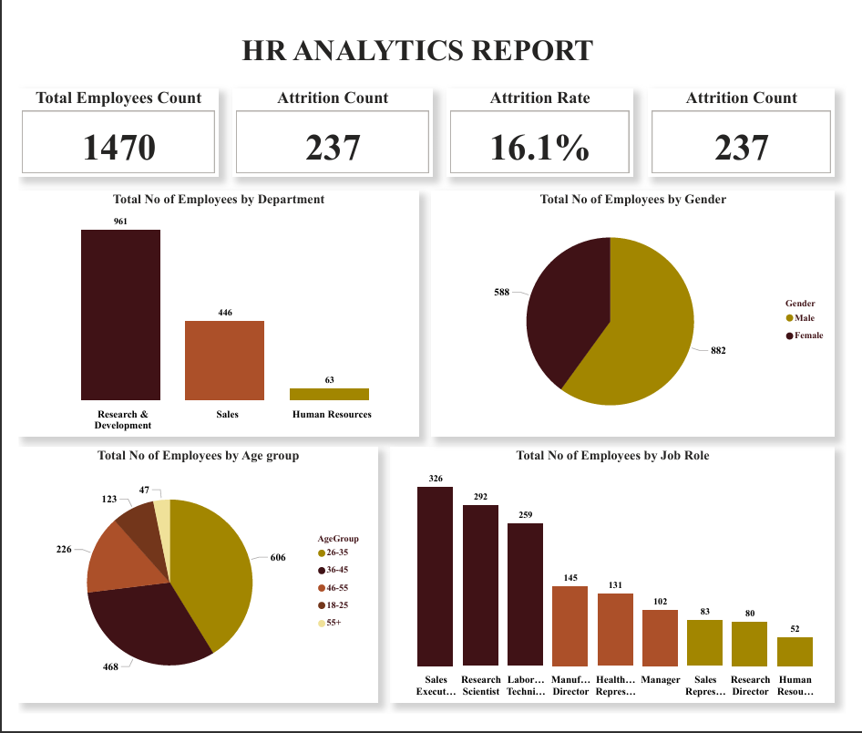

**Annex 2: Attrition Analysis Dashboard**

*This dashboard visualizes attrition by Job satisfaction, Age group, Gender and Department.*

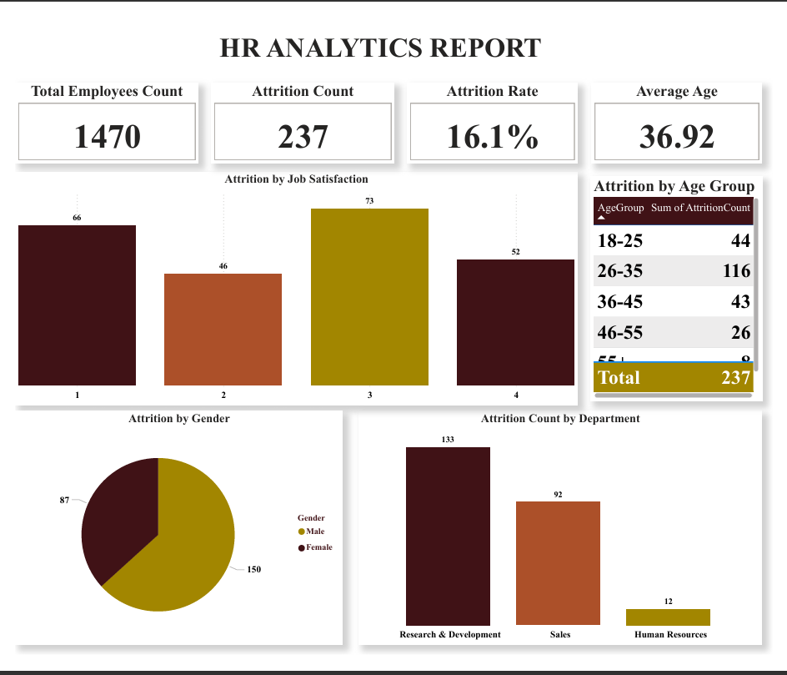

**Annex 3: Diversity Analysis Dashboard**

*This dashboard visualizes Education field distribution, Marital status distribution and Gender distribution.*

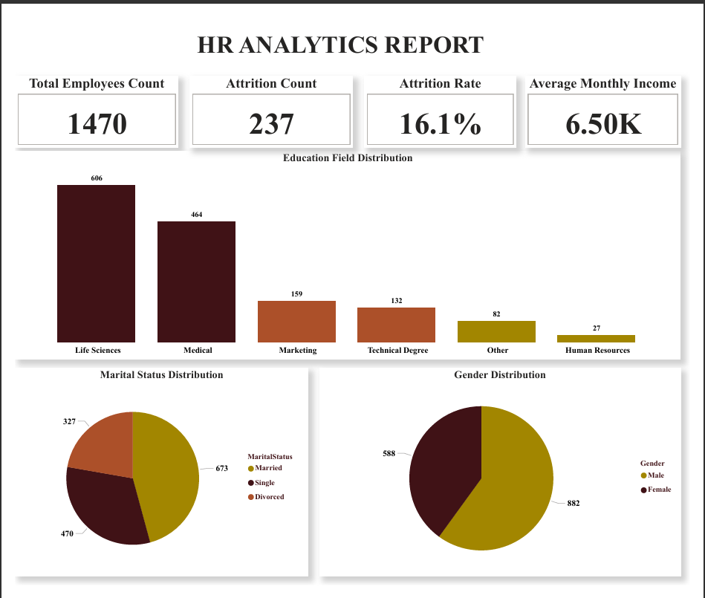

**Annex 4: Compensation Insights Dashboard**

*This dashboard visualizes Average salary by department, Overtime impact on average monthly income and Salary slab distribution.*

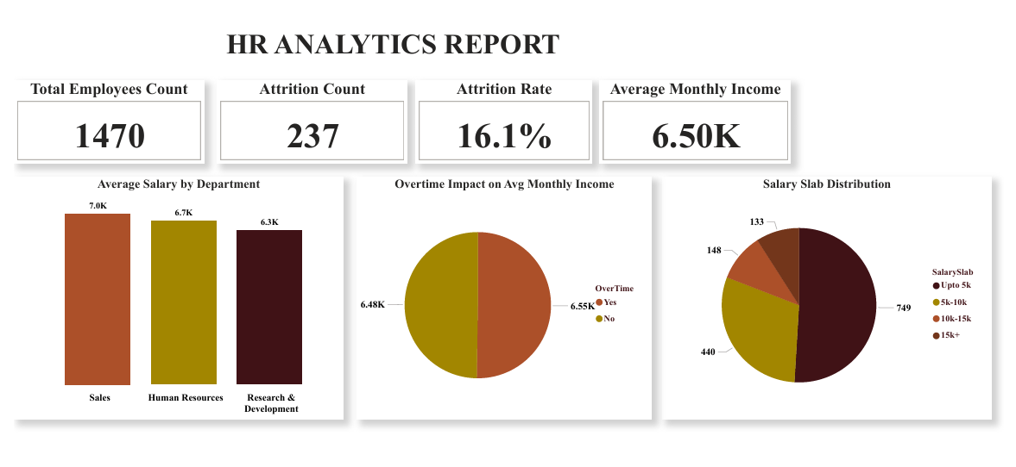

**Annex 5: Performance and Satisfaction Insights Dashboard**

*This dashboard visualizes Job satisfaction distribution and Work-life balance distribution.*

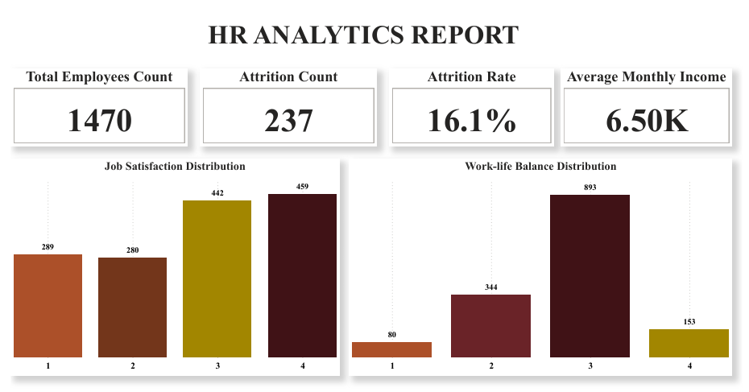

**Annex 6: Career and Tenure Insights Dashboard**

*This dashboard visualizes promotion overdue status, career growth map and Career length vs performance.*

